**Q-1 Circular Queue program.**

#include <stdio.h>

# define max 6

int queue[max]; // array declaration

int front=-1;

int rear=-1;

// function to insert an element in a circular queue

void enqueue(int element)

{

if(front==-1 && rear==-1) // condition to check queue is empty

{

front=0;

rear=0;

queue[rear]=element;

}

else if((rear+1)%max==front) // condition to check queue is full

{

printf("Queue is overflow..");

}

else

{

rear=(rear+1)%max; // rear is incremented

queue[rear]=element;

}

}

// function to delete the element from the queue

int dequeue()

{

if((front==-1) && (rear==-1)) // condition to check queue is empty

{

printf("\nQueue is underflow..");

}

else if(front==rear)

{

printf("\nThe dequeued element is %d", queue[front]);

front=-1;

rear=-1;

}

else

{

printf("\nThe dequeued element is %d", queue[front]);

front=(front+1)%max;

}

}

// function to display the elements of a queue

void display()

{

int i=front;

if(front==-1 && rear==-1)

{

printf("\n Queue is empty..");

}

else

{

printf("\nElements in a Queue are :");

while(i<=rear)

{

printf("%d,", queue[i]);

i=(i+1)%max;

}

}

}

int main()

{

int choice=1,x; // variables declaration

while(choice<4 && choice!=0) // while loop

{

printf("\n Press 1: Insert an element");

printf("\nPress 2: Delete an element");

printf("\nPress 3: Display the element");

printf("\nEnter your choice");

scanf("%d", &choice);

switch(choice)

{

case 1:

printf("Enter the element which is to be inserted:");

scanf("%d", &x);

enqueue(x);

break;

case 2:

dequeue();

break;

case 3:

display();

}}

return 0;

}

**Output:** 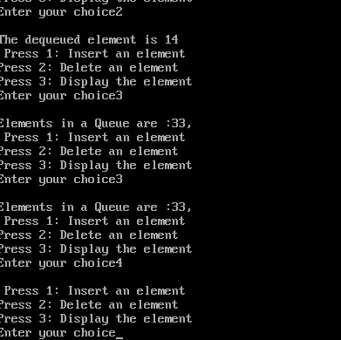

**Q-2.Program for deque.**

#include<stdio.h>

#include<conio.h>

#define SIZE 5

int items[SIZE];

int front = -1, rear = -1;

// Check if the queue is full

int isFull() {

if ((front == rear + 1) || (front == 0 && rear == SIZE - 1)) return 1;

return 0;

}

// Check if the queue is empty

int isEmpty() {

if (front == -1) return 1;

return 0;

}

// Adding an element

void enQueue(int element) {

if (isFull())

printf("\n Queue is full!! \n");

else {

if (front == -1) front = 0;

rear = (rear + 1) % SIZE;

items[rear] = element;

printf("\n Inserted -> %d", element);

}

}

// Removing an element

int deQueue() {

int element;

if (isEmpty()) {

printf("\n Queue is empty !! \n");

return (-1);

} else {

element = items[front];

if (front == rear) {

front = -1;

rear = -1;

}

// Q has only one element, so we reset the

// queue after dequeing it. ?

else {

front = (front + 1) % SIZE;

}

printf("\n Deleted element -> %d \n", element);

return (element);

}

}

// Display the queue

void display() {

int i;

if (isEmpty())

printf(" \n Empty Queue\n");

else {

printf("\n Front -> %d ", front);

printf("\n Items -> ");

for (i = front; i != rear; i = (i + 1) % SIZE) {

printf("%d ", items[i]);

}

printf("%d ", items[i]);

printf("\n Rear -> %d \n", rear);

}

}

void main() {

// Fails because front = -1

clrscr();

deQueue();

enQueue(1);

enQueue(2);

enQueue(3);

enQueue(4);

enQueue(5);

// Fails to enqueue because front == 0 && rear == SIZE - 1

enQueue(6);

display();

deQueue();

display();

enQueue(7);

display();

// Fails to enqueue because front == rear + 1

enQueue(8);

getch();

}

**Output:** 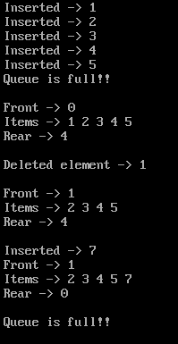

**Q-3.Program for priority queue.**

#include <stdio.h>

int size = 0;

void swap(int *a, int *b) {

int temp = *b;

*b = *a;

*a = temp;

}

// Function to heapify the tree

void heapify(int array[], int size, int i) {

if (size == 1) {

printf("Single element in the heap");

} else {

// Find the largest among root, left child and right child

int largest = i;

int l = 2 * i + 1;

int r = 2 * i + 2;

if (l < size && array[l] > array[largest])

largest = l;

if (r < size && array[r] > array[largest])

largest = r;

// Swap and continue heapifying if root is not largest

if (largest != i) {

swap(&array[i], &array[largest]);

heapify(array, size, largest);

}

}

}

// Function to insert an element into the tree

int i;

void insert(int array[], int newNum)

{

if (size == 0) {

array[0] = newNum;

size += 1;

} else {

array[size] = newNum;

size += 1;

for ( i = size / 2 - 1; i >= 0; i--) {

heapify(array, size, i);

}

}

}

// Function to delete an element from the tree

void deleteRoot(int array[], int num) {

int i;

for (i = 0; i < size; i++) {

if (num == array[i])

break;

}

swap(&array[i], &array[size - 1]);

size -= 1;

for ( i = size / 2 - 1; i >= 0; i--) {

heapify(array, size, i);

}

}

// Print the array

void printArray(int array[], int size) {

for ( i = 0; i < size; ++i)

printf("%d ", array[i]);

printf("\n");

}

// Driver code

int main() {

int array[10];

insert(array, 3);

insert(array, 4);

insert(array, 9);

insert(array, 5);

insert(array, 2);

printf("Max-Heap array: ");

printArray(array, size);

deleteRoot(array, 4);

printf("After deleting an element: ");

printArray(array, size);

getch();

}

**Output:** 